Rock Paper Scissor Spock Lizard
According to Wikipedia: Rock-paper-scissors-lizard-Spock is a five-gesture expansion of the classic selection method game rock-paper-scissors. It operates on the same basic principle, but includes two additional weapons: the lizard (formed by the hand as a sock-puppet-like mouth) and Spock (formed by the Star Trek Vulcan salute). This reduces the chances of a round ending in a tie. The game was invented by Sam Kass with Karen Bryla.
- The game was mentioned in three episodes of The Big Bang Theory. According to an interview with Kass, the series producers did not ask for permission to use the game, but he was later referenced in an episode in the fifth season.
The rules of the game are summarized in the following table:
Rock crushes lizard. | Rock crushes Scissors
Scissors decapitate lizard. | Scissors cuts Paper
Lizard eats Paper. | Lizard poisons Spock.
Spock vaporizes rock. | Spock bends scissors.
Paper disproves Spock. | Paper covers Rock

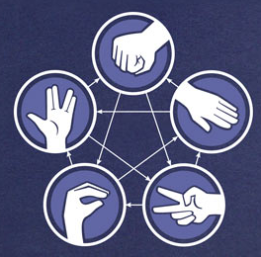
And both figures below depict the rules of the game
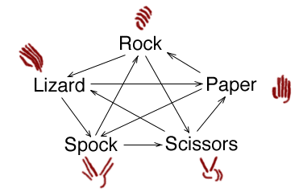

You have been given the completed Player class shown below:

public class Player
{
private String choice;
private String name;

/**
* Constructor for objects of class Player
*/
public Player(String n, String ch) {
name = n;
choice = ch;
}

public String getName() { return name; }

public String getChoice() { return choice; }
}

You have been given the partially completed RPSSL class. You are to implement the playRound method in the RPSSL class. The playRound method returns the name of the winning player. If both players select the same choice return “TIE”.
public class RPSSL
{
public String playRound(Player p1, Player p2)
{
}
}

Given the following code fragment:
RPSSL game = new RPSSL();

The following method calls | return the String
game.playRound(new Player("Sheldon", "rock"),  new Player("Leonard", "rock"); | “TIE”
game.playRound(new Player("Sheldon", "paper"),  new Player("Howard", "rock")); | "Sheldon"
game.playRound(new Player("Raj", "spock"),  new Player("Penny", "paper")); | "Penny"
game.playRound(new Player("Amy", "lizard"),  new Player("Leonard", "scissors")); | "Leonard"

- The choice will always be one of the five possibilities exactly as shown in the above table and listed below.
  - "rock"
  - "paper"
  - "scissors"
  - "spock"
  - "lizard"

